Bridge Construction
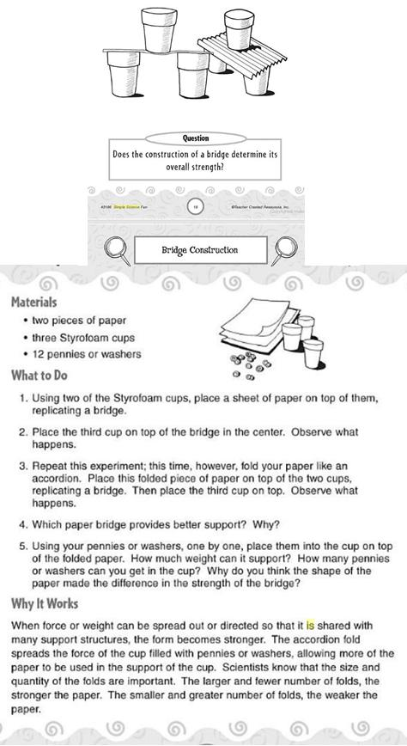

Source: Forbes, E., Hale, J. and Christianson, C. Creative Kids: Simple Science Fun. California: Teacher Created Resources, 2010. eBook.

